https://tinkoff.slack.com/archives/C482SKHJP/p1617789069069400
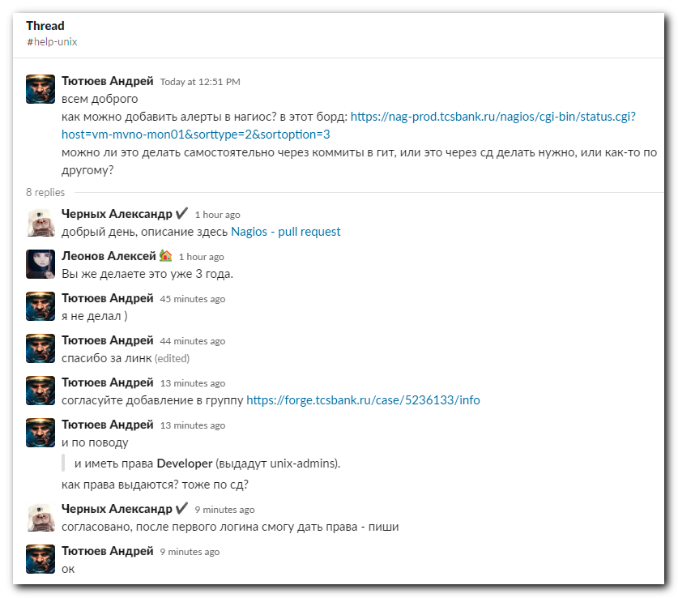

https://wiki.tcsbank.ru/display/DAS/Nagios+-+pull+request
Nagios - pull request
